Application to have a Gig Buddy
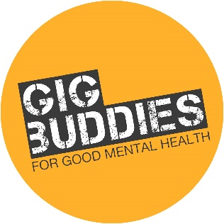
Please fill out the following form
Is this a referral? If so, please share the referrer’s details | Name of referrer:  Contact telephone number:  Email address:
Today’s date
Your name (participant)
Your date of birth
Your address (please include postcode)
Your telephone numbers | Home:  Mobile:
Your email address
What do you hope to get out of having a gig buddy?
Would you prefer your volunteer to be a woman, a man, somebody who doesn’t see themselves as either a man or woman? (Please put ‘no preference if none of the above)
How do you feel about crowds and loud music? (you can stick to quieter gigs if you'd like)
When was the last time you went to a concert or gig? (for example, last month, or more than 6 months ago)
How often do you go out with friends?(Please put weekly, monthly, occasionally or never)
What music are you into? For example rock, reggae, house, or any particular singers or bands
Would you like to try out new gigs and music you haven’t heard of?
What are your hobbies?
Please tell us about any difficult or challenging issues that you face relating to your mental health
Is there anything else that your buddy will need to know about the support you need?
Have you used statutory or formal Mental Health services before?
If you have any other specific needs or health issues, please tell us here:
Please rate the following statements by putting a number between 1 and 5 next to each one, with 1 being low and 5 being high.  (This will help us to assess the amount of support you might need) | I am confident in communicating with others:  I am capable and reliable in meeting appointments:  I am comfortable travelling independently (for example in using the night bus):  I am receiving enough support in my life to live fairly independently:  I am motivated to find activities that will improve my day-to-day well being:
Please share two emergency contacts who are involved in supporting you, and who you are happy for us to contact | Emergency contact 2  Name:  Relationship to you:  contact phone number:  Email:  Emergency contact 2  Name:  Relationship to you:  contact phone number:  Email:

Please note that the project is designed for individuals with mild to moderate mental health needs, who are able to live fairly independent lives but need an extra bit of support, social engagement and fun! Unfortunately, we are unable to support people with longer term, severe and enduring Mental Health issues at this time.

One of the team will be in touch with you shortly to talk about what happens next!

Thank you for contacting Gig Buddies for Good Mental Health.

Return this form to: GBMH, Synergy Creative Community, c/o Community Base, 113 Queens Road, Brighton, BN1 3XG
or email: info@gigbuddiesmentalhealth.org.uk
Telephone: 07877 574212

