Application to volunteer for…
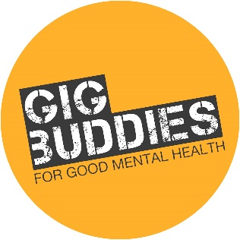
Please fill out the following form, and create a profile about yourself in the final section, making your language as accessible as possible in this section.

Name
Address
Telephone (home and mobile)
Email
Date of birth
Are you on social media (please name any twitter handles etc you’d like to connect through)
Do you have a driving licence and access to a car?
Are you willing to travel in order to volunteer? (either driving or public transport)
Do you have any health needs that we should be aware of?
Are you currently experiencing any mental health issues that we should be aware of?
Have you experienced or overcome any mental health difficulties in the past?
Please give us the name of an emergency contact for you | Name:  Relationship to you:  Telephone:  Address:
Are you happy for photos of you to be used to promote GBMH?
Please provide details of two referees: one referee you must know professionally, the other can be a friend (not family member). | Name:  Relationship to you:  Address:  Email:  Telephone:
Second referee | Name:  Relationship to you:  Address:  Email:  Telephone:
Criminal convictions

GBMH has to make sure that all our volunteers are safe to work with people with mental health needs – all information you give will be treated confidentially.
All Gig Buddies volunteers will need to have a police check through the Disclosure and Barring Service before they can start.
If you have a conviction we will need to meet and talk about it, but it won’t necessarily prevent you from volunteering. We will only take into account a criminal record if it could be important to your role as a Gig Buddy.
Have you ever been convicted of any criminal offence by a court of law? | Yes No  (If yes please give details)
Please declare | As far as I know, all information that I have provided on this form is correct.  Name:  Date:  Return this form to: GBMH, Synergy Creative Community, c/o Community Base, 113 Queens Road, Brighton, BN1 3XG  or email: info@gigbuddiesmentalhealth.org.uk  Telephone: 07877 574212

All about (write your name here)
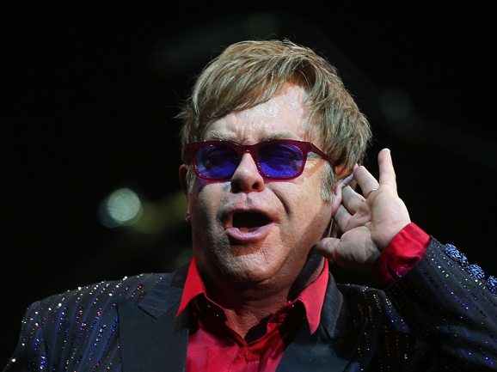
Replace this picture of Elton John with a photo of yourself

I live in… | Write the name of your town
I am aged | Write your age
Music I like
My hobbies and interests
Why I want to join gig buddies for good mental health!

Why I would be a good gig buddy! | You could list experiences you’ve had, things you’re good at and / or your personal qualities!

